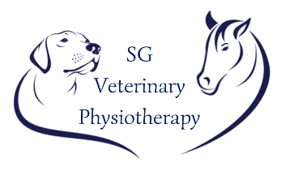

Sarah Guffogg
07701080101
Email: sarah@sgveterinaryphysiotherapy.co.uk

CLIENT DETAILS
Name

Address

Tel. No.

Email
Animals Name

Does the animal suffer from any of the following?

Heart condition
Epilepsy
Skin allergies
Food allergies
Photosensitivity
Tumour/lesion

Do you consent to the animal receiving the following:
Physiotherapy Hydrotherapy (companion animals)

Please give as much detail as possible about the animals condition and attach any relevant clinical history/x-rays/scans:

Medications:

Veterinary Details
Name: |  | Practice:
Signature: |  | Date:

